
SSO Configuration
Check

Snyk Platform for Fed Practice

This report has been produced by TCS for DSG
Adversarial Testing
KPMG US

PPA - 920340
PTI - 920689
RP - 920356

SSO Configuration Check, Initial
04/16/2026

This report is to assist with vulnerability remediation activities. This report does not carry an endorsement from the KPMG US Adversarial Testing Team.

This report is for KPMG INTERNAL USE ONLY and its content cannot be shared or distributed in any form with a third-party client or vendor without initiating the client inquiry process.

Contents
Executive Summary 1
Background and Scope 1
Summary of Findings 1
Assessment Details 2
Detailed Findings 3
Appendix 8
Risk Rating Criteria 9
Terminology 10
Methodology 11
DSG Disclaimer Notice 12

Assessment Overview
Timeline
Assessment Start Date | 04/13/2026
Assessment Completion Date | 04/16/2026
Report Completion | 04/16/2026
Team
Name | Role | Email
Pranshu Raghav | Tester | pranshuraghav@kpmg.com
Report History
Name | Company | Date | Description
Pranshu Raghav | TCS | 04/16/2026 | Initial Report

Executive Summary

Background and Scope
As part of the Digital Security Group’s (DSG) Adversarial Testing Program, TCS conducted a manual vulnerability assessment and penetration test of the Federal Pricing tool application.
The TCS team performed time-boxed security testing using a hybrid model of manual testing and automated scanning. For its automated analysis, TCS leveraged industry-standard tools, including HCL AppScan and other open-source testing software. The purpose of this engagement was to identify potential vulnerabilities within the application. The manual assessment complemented the automated scans, covering key areas such as information gathering, configuration management, authentication, authorization, session management, and input validation to identify security issues that scould affect the application.
The TCS team identified a total of <number> findings (from both automated and manual testing), which were categorized across various severity levels. During the automated scan, the tools analyzed <number> links and generated <number> initial findings. Of these, <number> were validated and reported, <number> were deemed Informational, and the rest were confirmed as false positives.

Summary of Findings
During this assessment, <word number> (<#>) findings across all phases of testing were identified. Each finding has been classified into categories of Very High, High, Medium, Low, and Informational (<#> Very High, <#> High, <#> Medium, <#> Low, <#> Informational) based on the risk level.
The table below details the findings discovered during the assessment. Each finding has been assigned a risk rating based on its potential impact to the firm and the likelihood of exploitation. These ratings provide a baseline for prioritization but should be evaluated within the broader context of the organization's security posture and existing compensating controls. The results of this assessment represent a point-in-time analysis of the application's security.
# | Finding | Dependency | Prior Test | Likelihood | Impact | Risk Rating
1 | SAML Assertion Not Encrypted | Microsoft Entra ID | NA | Low | Minor | Low
2 | 65-Minute SAML Assertion Validity Window (Replay Blocked) | Microsoft Entra ID | NA | Medium | Minor | Low
3 | Third-Party Session Recording on Auth Pages | Application | NA | Medium | Minor | Low
4 | Internal/Hidden API Endpoints Exposed | Application | NA | Medium | Minor | Low
5 | CSP Permits unsafe-inline and unsafe-eval | Application | NA | Medium | Minor | Low
6. | Web Server Version and Infrastructure Disclosure | Application / Okta / Microsoft | NA | High | Minor | Low
7. | Sensitive Information (Tokens) Displayed in URL | Okta | NA | Medium | Minor | Low
8 | Okta PIV/Certificate Authentication Endpoint Active and Exposed | Okta | NA | Medium | Minor | Low
9. | DNS Certification Authority Authorization (CAA) Record Missing | No | New | Low | Low | Low  Low
10. | HSTS Not Submitted to Browser Preload Lists | No | New | Medium | Low | Low  ow
11. | OCSP Stapling Not Enabled | No | New | Low | Low | L Low ow
12. | RSA 2048-bit Key — Plan Migration to Stronger Algorithm | No | New | N/A | N/A | Infor Informational mational
13. | SSL Certificate Expiry in Approximately 4.5 Months | No | New | N/A | N/A | Inform Informational ational
14. | Concurrent User Session | Okta | NA | Low | Negligible | Informational

Notes: NA.

Limitations: NA

Disclaimer: This report contains examples of instances where certain vulnerabilities have been identified. However, the issue may not be only limited to the instances reported. We certainly advise that a global fix be implemented to remediate all vulnerabilities and not limit the remediation to just the instances identified in this report

Assessment Details
In addition to the findings summarized above, several assessment parameters provide context for the scope and configuration of the test. These details outline the environment, roles, and conditions under which the application was evaluated and should be considered when reviewing the overall results. The table below captures the key inputs and constraints of the assessment.

Field | Details
Test URL | https://app.snykgov.io
Testing Environment | Dev
Number of Access Level in Scope | NA
User Roles | pranshuraghav@kpmg.com  user1testad1@dev.uskgc.com  user3testad3@dev.uskgc.com
Scope of Test | SSO
Testing Window | 04/13/2026 to 04/16/2026
Point of Contact (App Team) | Solomon, Abigail

Detailed Findings

Finding 1: SAML Assertion Transmitted in Plaintext (Not Encrypted)
Low
Dependency: Microsoft
Status: Open Description:
Testing identified that the SAML assertion issued by Microsoft Entra ID is signed (2 signatures: Response + Assertion level) but not encrypted. The entire assertion including user PII is transmitted as plaintext Base64 in the HTTP POST body. Any entity with access to the SAML response can decode and read the full assertion without any key.
Affected Systems & Locations:
https://snyk-fedramp.okta.com/sso/saml2/ (SAML response)
Reproduction Steps:

- Intercept the POST to snyk-fedramp.okta.com/sso/saml2/0************** containing the SAMLResponse parameter.

- Copy the SAMLResponse value and Base64 decode it.

- Observe that the full SAML assertion is readable in plaintext including NameID, user attributes, and authentication context.

- Confirm <EncryptedAssertion> element is NOT present in the decoded XML by reading it from SAML Raider

Screenshots:

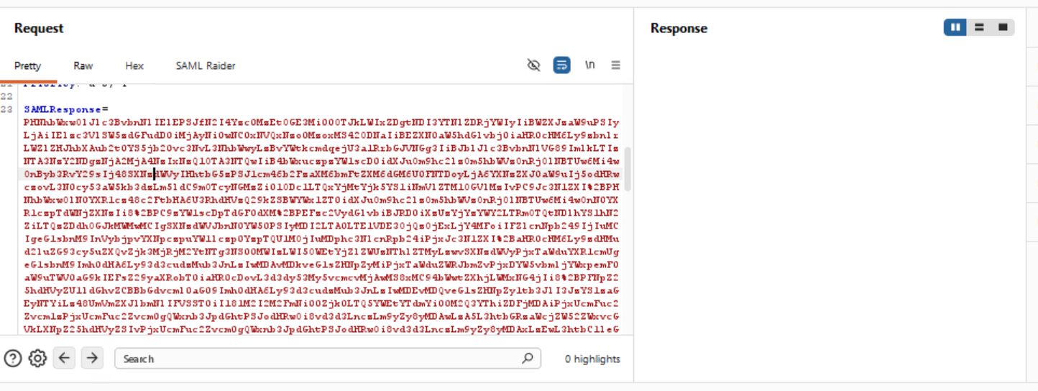
Figure 1

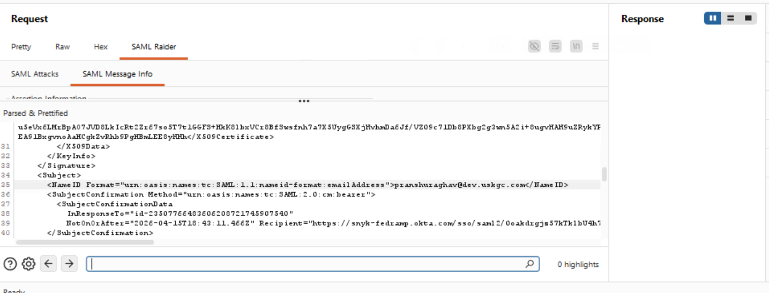
Figure 2

Remediation:

As a security hardening best practice for FedRAMP environments:
- Configure Microsoft Entra ID to encrypt SAML assertions for the Okta SP application.
- Upload Okta SP’s encryption certificate from the SAML metadata to Azure AD’s Token Encryption settings.
- Use AES-256-CBC or AES-256-GCM for assertion encryption. This adds application-layer confidentiality on top of the existing TLS transport encryption.

Closing/Downgrading Justification:

Finding 2: 65-Minute SAML Validity Window
Low
Dependency: Microsoft Entra ID
Status: Open Description:
Testing identified that the SAML assertion has a validity window of 65 minutes (NotBefore=”2026-04-1515T17:38:11.466Z ” NotOnOrAfter: “2026-04-15T18:43:11.466Z”. This includes a 5-minute clock skew allowance and a 60-minute forward window. Industry best practice recommends 5–10 minutes. Replay testing was performed to validate the practical exploitability of this window. The captured SAML assertion was re-submitted to the Okta SP endpoint (POST /sso/saml2/0oakdrgjz57kTklbU4h7) via Burp Repeater approximately 3 minutes after the original authentication. Despite the 65-minute validity window, replayed assertions are rejected.
Affected Systems & Locations:
https://snyk-fedramp.okta.com/sso/saml2/ (SAML response)
Reproduction Steps:

- Intercept the SAML Response POST in Burp Suite during live SSO authentication.
- Base64 decode the SAML Response and locate the <Conditions> element.
- Note NotBefore (2026-04-13T06:12:58.201Z) and NotOnOrAfter (2026-04-13T07:17:58.201Z) — 65-minute window
- Note the original authentication to complete (forward the request to the browser).
- In Burp Repeater, re-send the identical SAML POST within the 65-minute window (tested at ~3 minutes after issuance).
- Observe the response: HTTP 400 "Login Failed - GENERAL_NONSUCCESS".
- Result: Okta rejected the replayed assertion. One-time-use enforcement is active.

Screenshots:
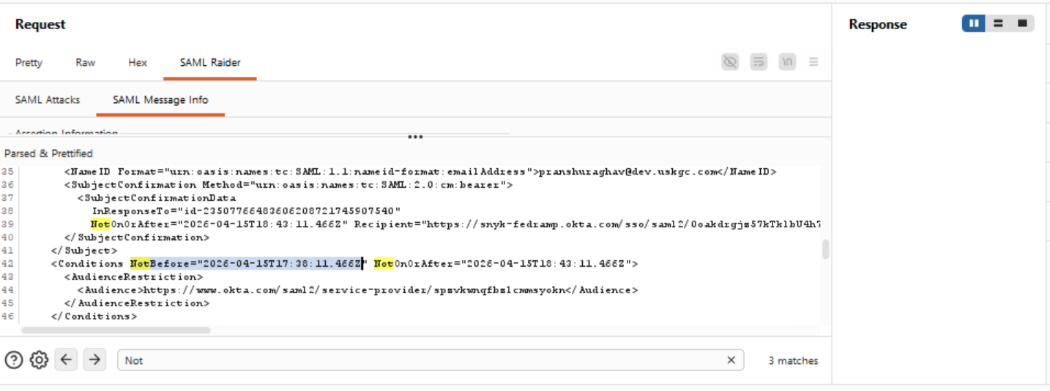

Figure 1

Remediation:

As a security hardening best practice, reduce the SAML assertion validity window to 5–10 minutes in the Microsoft Entra ID SAML configuration.
- Note: Okta’s one-time-use enforcement (confirmed via replay testing) provides effective replay protection regardless of the window duration. This recommendation is for defense-in-depth alignment with NIST SP 800-63C.

Closing/Downgrading Justification:

Finding 3: Third Party Session Recording on Authentication Page
Low
Dependency: Application
Status: Open
Description:
Testing identified that the Snyk login and post-authentication pages load JavaScript from third-party domains with full DOM access during the authentication flow:
FullStory (edge.fullstory.com) — Session recording, Org ID: RX2JA
Sentry (js.sentry-cdn.com) — Error monitoring
Segment (segment.com) — Analytics
FullStory actively records session data, confirmed by POST requests to rs.fullstory.com/rec/page during the authentication flow. These scripts execute in the same origin as the auth pages and can access DOM content including SSO parameters.
Affected Systems & Locations:

https://app.snykgov.io/login
https://app.snykgov.io/auth/okta/callback
Reproduction Steps:

- Navigate to app.snykgov.io/login with Burp proxy active.
- Observe requests to edge.fullstory.com/s/fs.js and js.sentry-cdn.com loaded on the page.
- Observe POST to rs.fullstory.com/rec/page confirming active session recording.
- Confirm no Subresource Integrity (SRI) hashes are present on these script tags.
Screenshots:
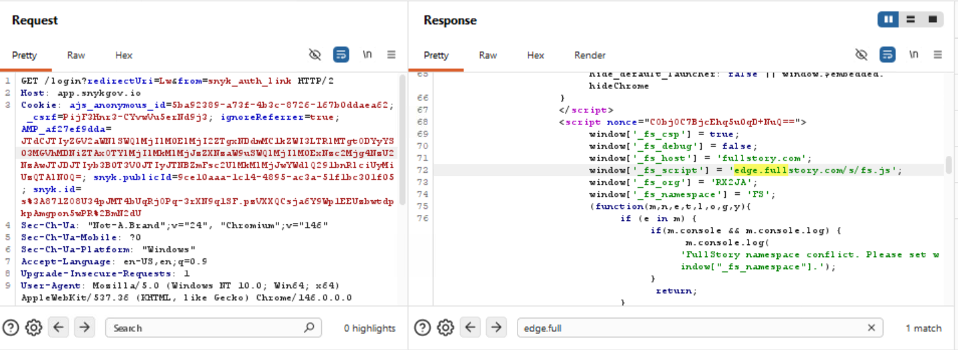

Figure 1
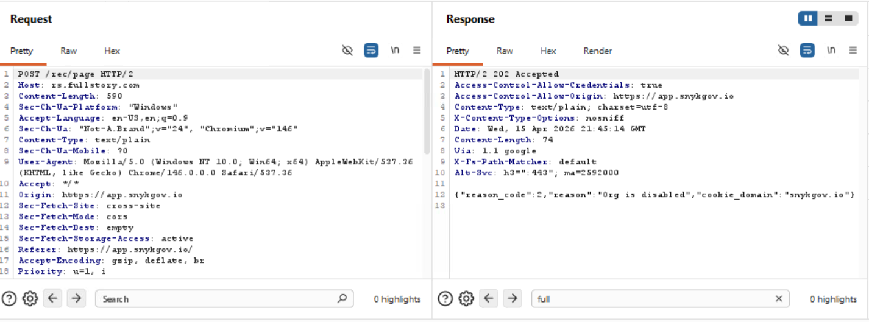
Figure 2

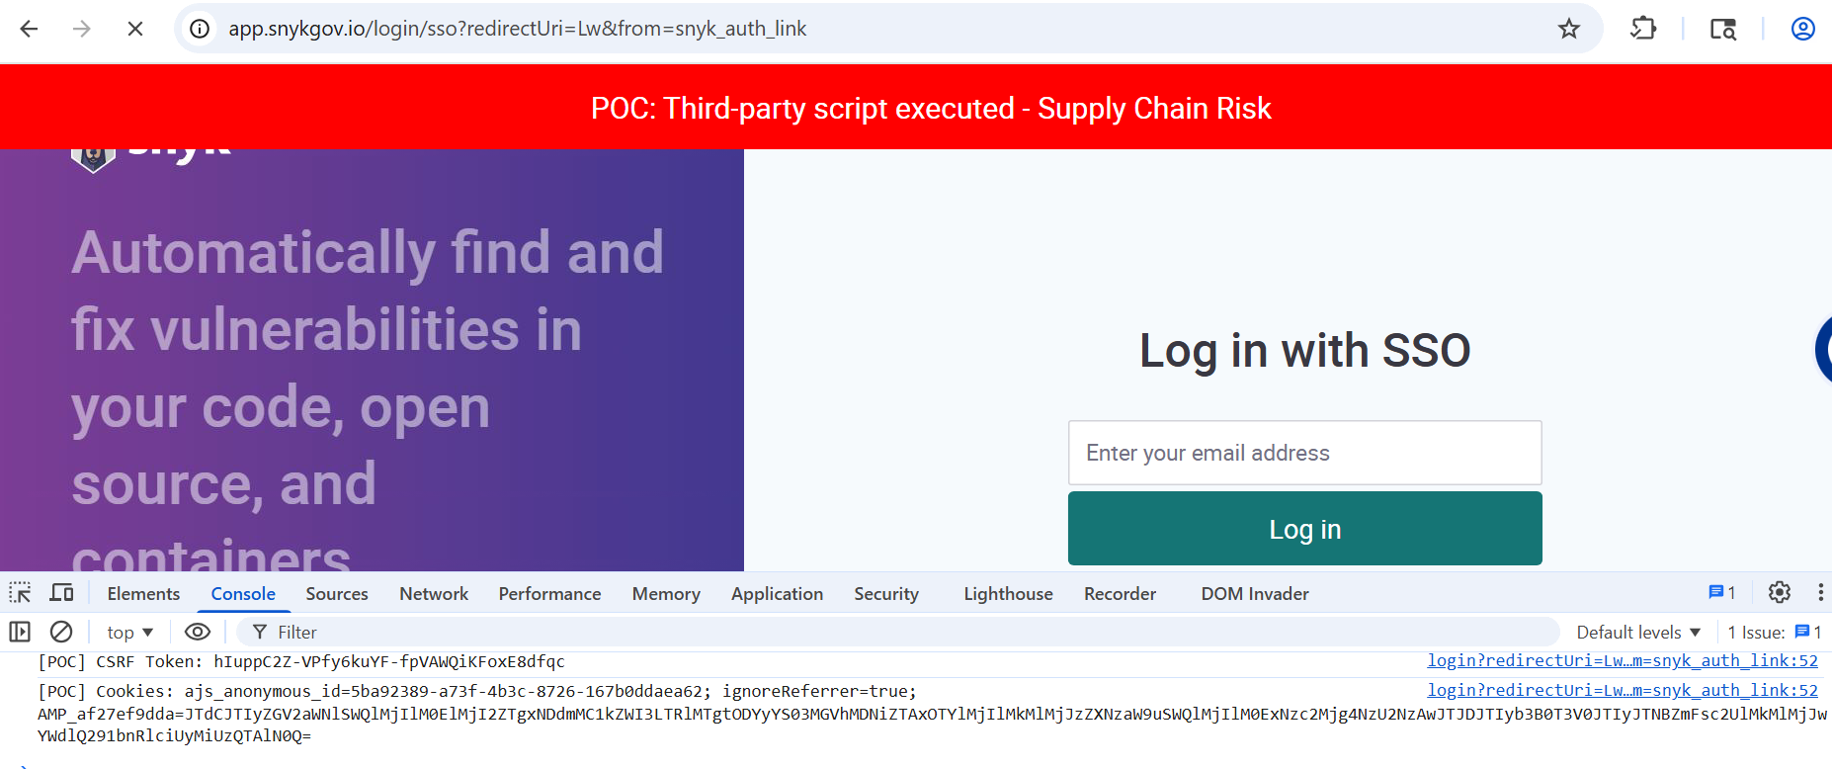
Figure 3

Remediation:

Exclude authentication pages (/login, /auth/*) from FullStory session recording.
- Implement Subresource Integrity (SRI) hashes for all third-party scripts.
- Review FedRAMP SSP for third-party data handling obligations on authentication flows.

Closing/Downgrading Justification:

Finding 4: Internal/Hidden API Endpoints Accessible Post-Authentication
Low
Dependency: Application
Status: Open
Description:
Testing identified that after authentication, the Snyk web application makes requests to /api/hidden/* endpoints that expose entitlement decisions, feature flag evaluations, and group enumeration. The "hidden" path prefix suggests internal APIs that may not have the same security review as public endpoints.
Endpoints observed:
/api/hidden/groups (with limit=100, group enumeration)
/api/hidden/groups/{id}/entitlements/decision
/api/hidden/release_flags/evaluation
Affected Systems & Locations:

https://app.snykgov.io/api/hidden/groups
https://app.snykgov.io/api/hidden/release_flags/evaluation
Reproduction Steps:

- Authenticate to app.snykgov.io through the SSO flow
- Observe network traffic in Burp Suite proxy.
- Identify GET /api/hidden/groups?limit=100&sort_by=name&sort_order=ASC requests
- Identify POST /api/hidden/release_flags/evaluation requests.
- Confirm these endpoints return data revealing organizational structure and feature flags.
Screenshots:
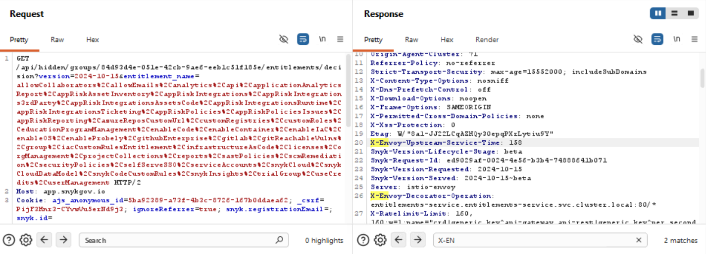

Figure 1
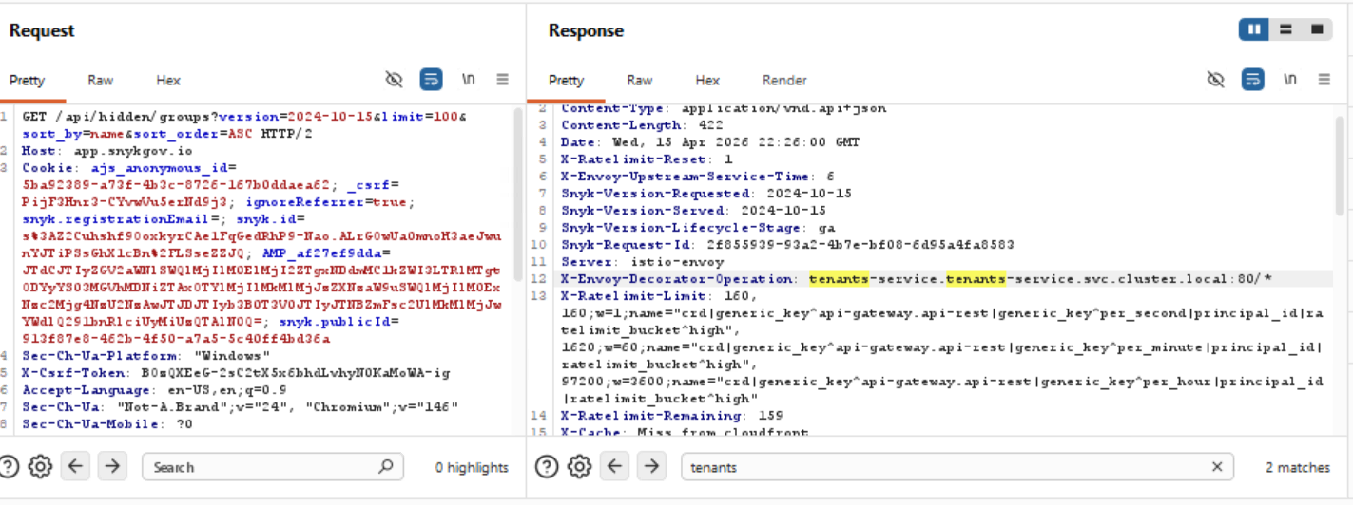
Figure 2
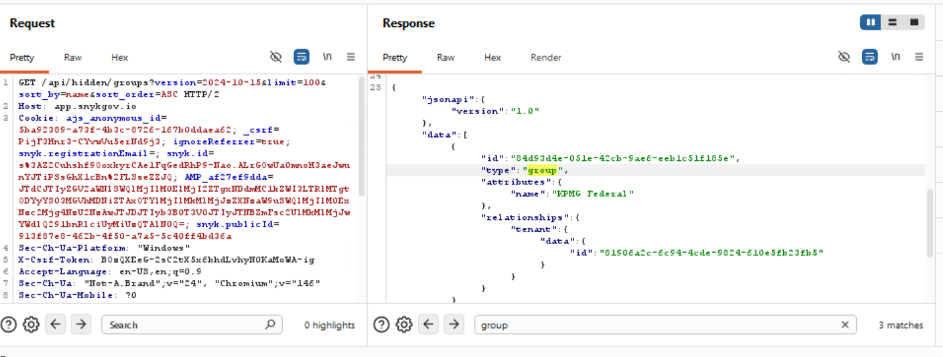
Figure 3

Remediation:

Review authorization controls on /api/hidden/* endpoints.
- Evaluate whether these endpoints should be accessible to browser-based clients.
- Consider renaming the path prefix to avoid signaling internal/undocumented status.

Closing/Downgrading Justification:

Finding 5: Content Security Policy Permits unsafe-inline and unsafe-eval
Low
Dependency: Application
Status: Open
Description:
Testing identified that the Content-Security-Policy header includes 'unsafe-inline' and 'unsafe-eval' in the script-src directive:
script-src 'self' 'nonce-7YyCILYpQ3Q/Z/U6zvTCAg==' 'unsafe-inline' 'unsafe-eval' 'strict-dynamic' 'report-sample'
While CSP Level 3 browsers ignore unsafe-inline when a nonce is present, CSP Level 2 browsers honor it. The Permissions-Policy header is also not present. Other security headers (HSTS, X-Frame-Options, X-Content-Type-Options, Referrer-Policy, Cache-Control) are correctly configured.
Affected Systems & Locations:

https://app.snykgov.io
Reproduction Steps:

- Send a request to app.snykgov.io using Burp Suite.
- Observe the Content-Security-Policy response header.
- Confirm 'unsafe-inline' and 'unsafe-eval' are present in the script-src directive.
- Confirm Permissions-Policy header is absent.
Screenshots:
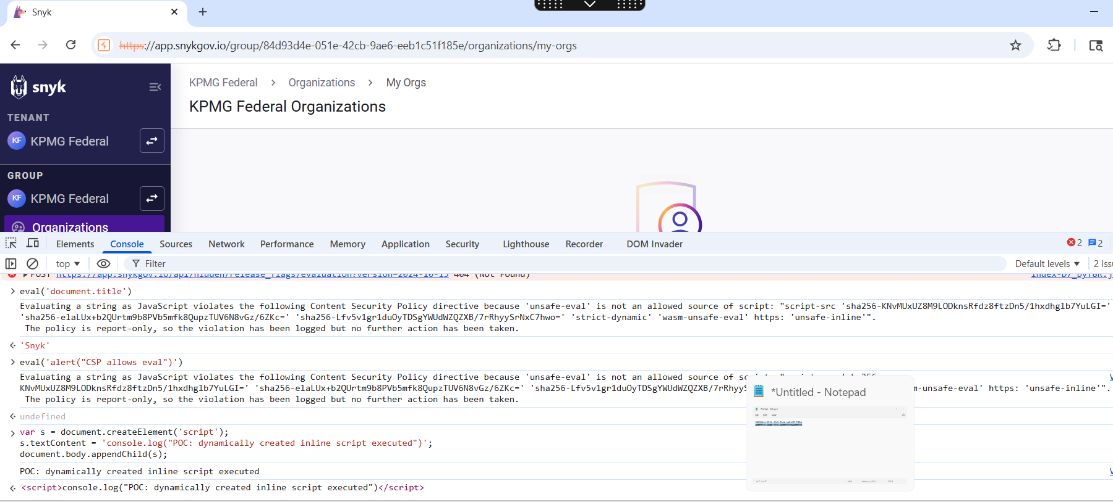

Figure 1
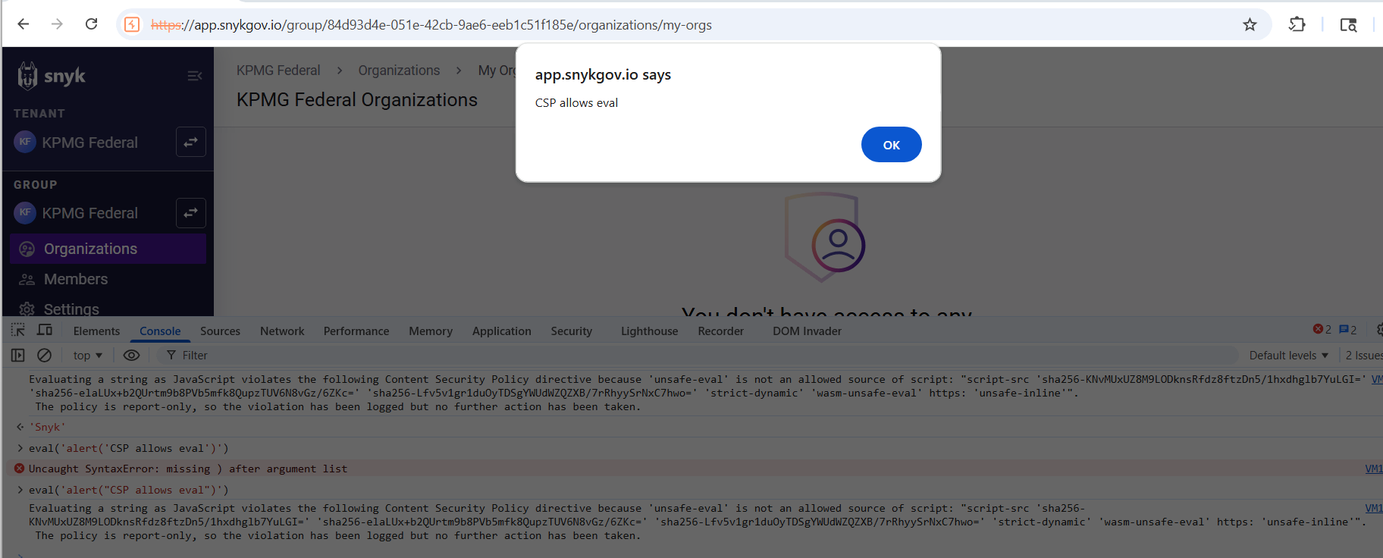
Figure 2

Remediation:

Remove 'unsafe-inline' and 'unsafe-eval' from CSP script-src.
- Rely on nonce-based loading with 'strict-dynamic'.
- Add a Permissions-Policy header.
- Remove deprecated X-XSS-Protection: 1; mode=block header.

Closing/Downgrading Justification:

Finding 6: Web Server Version and Infrastructure Disclosure
Low
Dependency: Application/Okta/Microsoft
Status: Open
Description:
Testing identified that multiple servers in the SSO chain return HTTP headers disclosing software versions, build numbers, datacenter regions, and infrastructure architecture:
Server: nginx — Snyk frontend
Server: istio-envoy — Snyk API, reveals Kubernetes + Istio
Server: AmazonS3 — Static assets
Server: Microsoft-HTTPAPI/2.0 — Microsoft Entra ID
Server: 2.1.23906.2 - USGVA ProdSlices — Exact build + US Gov Virginia
Server: 2.1.23906.2 - USGTX ProdSlices — US Gov Texas
Server: 2.1.23906.2 - USGAZLR2 ProdSlices — US Gov Arizona
Via: 1.1 *.cloudfront.net (CloudFront) — CDN node IDs exposed
Affected Systems & Locations:

https://app.snykgov.io
https://snyk-fedramp.okta.com
https://login.microsoftonline.us
Reproduction Steps:

- Send requests to each host in the SSO chain using Burp Suite or curl.
- Observe the Server response header on each response.
- Identify nginx, istio-envoy, AmazonS3, and Microsoft-HTTPAPI/2.0 disclosures.

- Note the Microsoft login server returns exact build version and datacenter region (e.g., 2.1.23906.2 - USGVA ProdSlices).
- Check Via headers for CloudFront node identifier disclosure.

Screenshots:
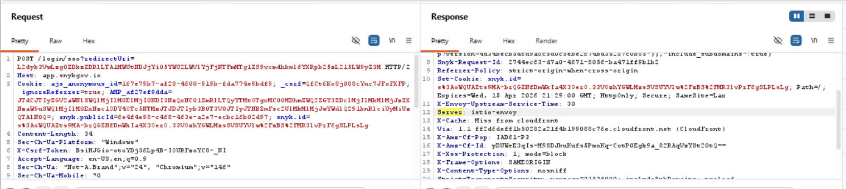

Figure 1

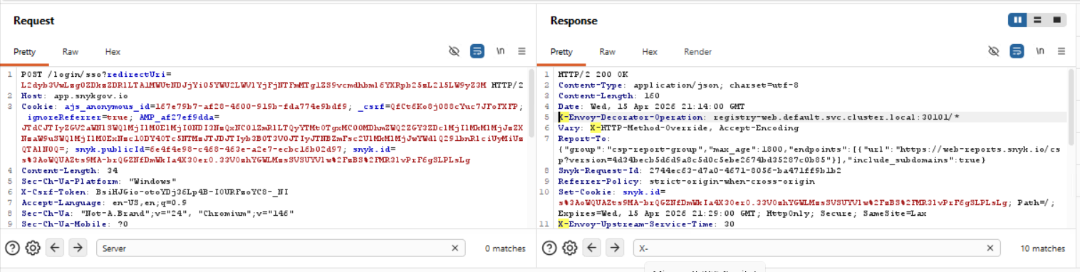

Figure 2

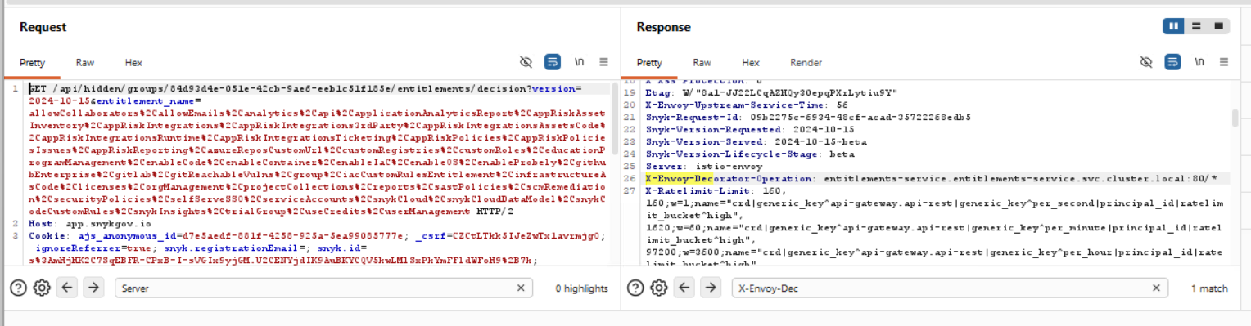

Figure 3
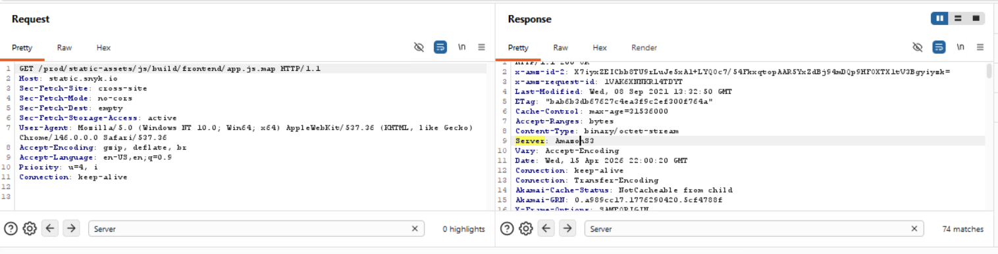

Figure 4
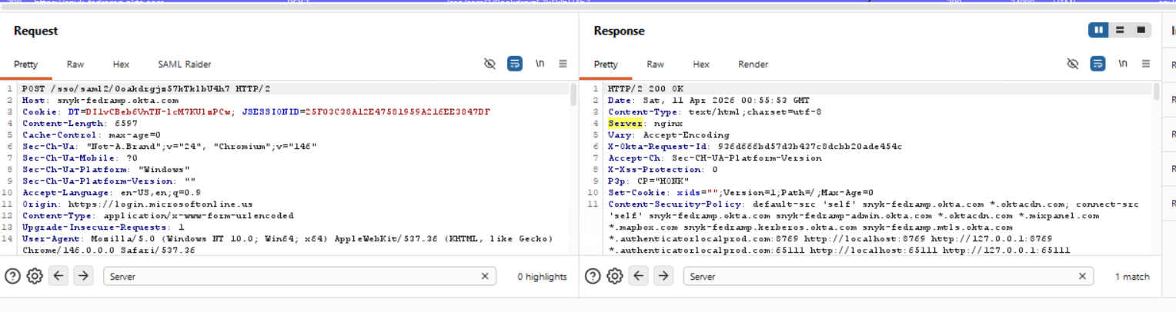

Figure 5

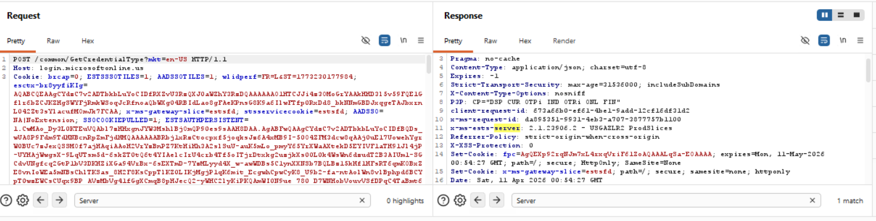

Figure 6

Remediation:

Snyk: Configure nginx with server_tokens off. Configure Istio/Envoy to suppress Server header via EnvoyFilter.
- CloudFront: Consider Lambda@Edge to strip Via header node identifiers.
- Microsoft: The Server header with build/region details is Microsoft platform behavior. Document as accepted risk or raise with Microsoft support for GovCloud.

Closing/Downgrading Justification:

Finding 7: Sensitive Information (Tokens) Displayed in URL
Low
Dependency: Okta
Status: Open
Description:
Testing identified that the SSO authentication flow transmits sensitive authentication tokens as query string parameters in GET request URLs. Information passed in URL query strings is logged in browser history, web server access logs, proxy logs, and is susceptible to shoulder surfing.
Tokens observed in URLs:
1. Okta stateToken: GET /login/token/redirect?stateToken=02H0Z4JikLJH5egJDl5Ayh6V_qn7XPFR8j1S8mWBtc (5x)
2. stateTokenExternalId: GET /sso/idps/0oakdrgjz57kTklbU4h7?stateTokenExternalId=RUczL0I4dEpx... (11x)
3. OAuth authorization code: GET /auth/okta/callback?code=kCa4o_nCIju5SeSkGAkLWw... (4x)
Mitigating factor: Referrer-Policy: strict-origin-when-cross-origin is correctly set, preventing token leakage to third-party domains via Referer headers.

Affected Systems & Locations:

https://snyk-fedramp.okta.com/login/token/redirect
https://snyk-fedramp.okta.com/sso/idps/
https://app.snykgov.io/auth/okta/callback
Reproduction Steps:

- Configure Burp Suite to intercept all SSO traffic.
- Complete a full SSO login flow..
- Review the Burp HTTP history for requests containing stateToken, stateTokenExternalId, and code parameters in the URL
- Confirm these sensitive tokens are visible in the browser address bar and would be logged in server access logs.

Screenshots:
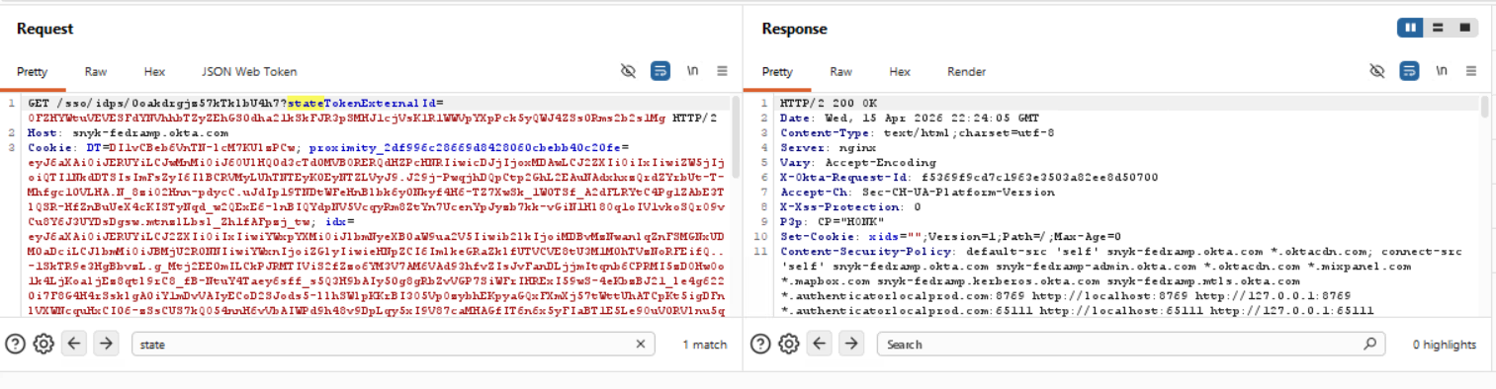
Figure 1

Remediation:

OAuth authorization code: Switch from response_mode=query (default) to response_mode=form_post on the Okta OAuth 2.0 application. This transmits the code in a POST body instead of the URL.
- Okta stateToken / stateTokenExternalId: This is Okta platform behavior. Raise a product enhancement request with Okta support. Document as accepted risk from third-party IdP.
- Ensure Referrer-Policy: strict-origin-when-cross-origin remains enforced (currently in place).

Closing/Downgrading Justification:

Finding 8: Okta PIV/Certificate Authentication Endpoint Active and Exposed
Low
Dependency: Okta
Status: Open
Description:
Testing identified that the Okta certificate authentication endpoint (/login/cert) is fully active and returns a functional PIV Card authentication page when accessed directly.
A POST request to /login/cert with the fromURI parameter returns HTTP 200 with a complete certificate authentication page titled "snyk-fedramp - Certificate authentication". The page reveals:
1. PIV Card / Smart card authentication is enabled and functional on the Okta org
2. The mutual TLS (mTLS) endpoint is disclosed: https://snyk-fedramp.mtls.okta.com/auth/cert/primaryAuth
3. The form auto-submits after 100ms via JavaScript (setTimeout form.submit, 100) — no user interaction required
4. Internal configuration parameters are exposed: isMobileClientLogin=false, isCustomDomain=false, rememberDevice=false, serverStatus=ACTIVE
5. The SAML relay endpoint is confirmed: fromURI points to snyk-fedramp.okta.com/sso/saml2/0oakdrgjz57kTklbU4h7

This represents an alternative authentication path that bypasses the standard Microsoft SSO + MFA chain. An attacker with a stolen or cloned PIV card could authenticate directly via this endpoint without going through the Microsoft identity provider.
Affected Systems & Locations:

https://snyk-fedramp.okta.com/login/cert
https://snyk-fedramp.mtls.okta.com/auth/cert/primaryAuth

Reproduction Steps:

- In Burp Repeater, send: POST /login/cert to snyk-fedramp.okta.com with body fromURI=https://snyk-fedramp.okta.com/sso/saml2/0oakdrgjz57kTklbU4h7.
- Observe HTTP 200 response with full PIV Card authentication page.
- Note the page title: "snyk-fedramp - Certificate authentication".
- Note the form action pointing to: https://snyk-fedramp.mtls.okta.com/auth/cert/primaryAuth (mTLS endpoint disclosed).
- Note the auto-submit JavaScript: setTimeout(function(){ form.submit(); }, 100) — form submits without user interaction
- Note the repost parameters exposing internal config: isMobileClientLogin, isCustomDomain, rememberDevice.
- Note the Okta org config: serverStatus=ACTIVE, isPreview=false (confirms production environment).

Screenshots:
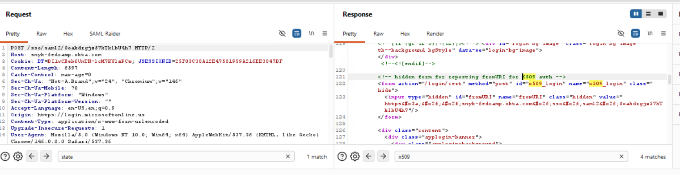
Figure 1
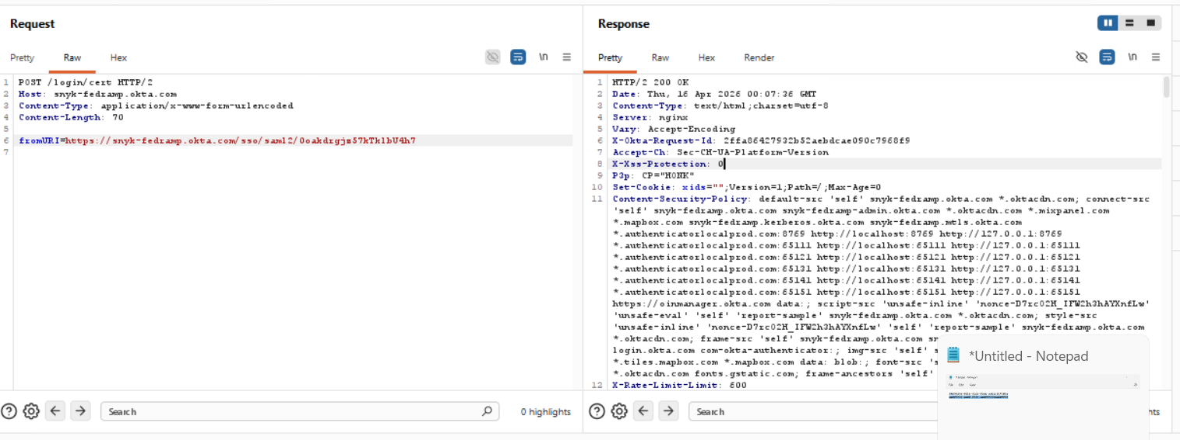
Figure 2

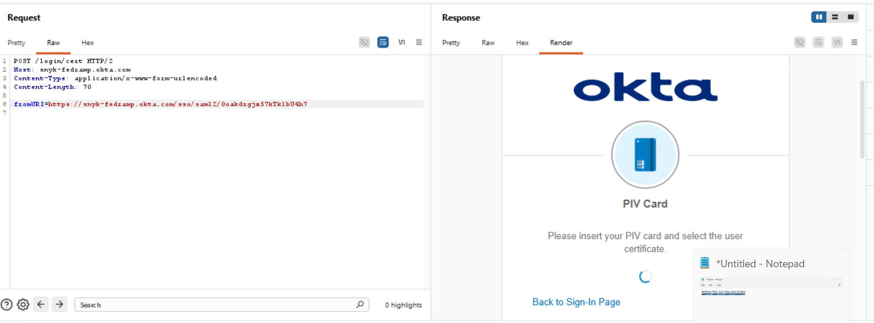
Figure 3

Remediation:

If PIV/certificate authentication is not required for Snyk SSO, disable it in the Okta application routing rules.
- If PIV auth IS required, restrict access to /login/cert to only users with valid client certificates at the network level.
- Remove or gate the auto-submit behavior — add user confirmation before form submission.
- Suppress internal configuration parameters (isMobileClientLogin, isCustomDomain, rememberDevice, serverStatus) from the response body.
- Consider restricting direct access to the mTLS endpoint (snyk-fedramp.mtls.okta.com) to authorized network ranges only.

Closing/Downgrading Justification:

Finding 9: DNS Certification Authority Authorization (CAA) Record Missing
Low
Dependency: Okta
Status: Open
Description:
The domain snykgov.io does not have a DNS Certification Authority Authorization (CAA) record configured. A CAA record instructs compliant Certificate Authorities (CAs) which organizations are authorized to issue TLS certificates for the domain. Without this control, any publicly trusted CA could technically issue a certificate for snykgov.io, increasing the risk of fraudulent or erroneous certificate issuance.
Affected Systems & Locations:

app.snykgov.io
Reproduction Steps:

- Query the current DNS records: dig CAA snykgov.io
- Confirm no CAA record is returned in the ANSWER section

Remediation:
- Add a DNS CAA record permitting only Amazon's CA to issue certificates: snykgov.io. CAA 0 issue “amazontrust.com"
- Add a corresponding issuewild entry for wildcard certificates: snykgov.io. CAA 0 issuewild amazontrust.com"
- Optionally configure an iodef entry to receive notifications of unauthorised issuance attempts.
- Verify the record is visible via public DNS resolvers after propagation.
Closing/Downgrading Justification:

Finding 10: HTTP Strict Transport Security (HSTS) Not Submitted to Browser Preload Lists
Low
Dependency: Okta
Status: Open
Description:
The server correctly returns an HSTS header (max-age=31536000; include SubDomains; preload), which satisfies the technical prerequisites for preload list inclusion. However, the domain has not been submitted to the HSTS preload lists maintained by Chrome, Edge, Firefox, or Internet Explorer.
Until the domain is added to these lists, first-time visitors who have never previously connected to the site are not protected by HSTS. An active network attacker positioned before the first connection (e.g., on a public Wi-Fi network) could perform an SSL stripping attack against that initial request.
Affected Systems & Locations:

app.snykgov.io
Reproduction Steps:

- Visit https://hstspreload.org and enter snykgov.io
- Confirm the eligibility check shows 'Preload list status: Not in preload list'.

Remediation:
- Submit snykgov.io for HSTS preloading at https://hstspreload.org
- Ensure the HSTS header remains correctly configured with max-age >= 31536000, include SubDomains, and preload directives before submission.
- Note that preload list inclusion is permanent — confirm all subdomains fully support HTTPS before submitting.
- Monitor submission status; propagation to all browsers typically takes 2–4 weeks.
Closing/Downgrading Justification:

Finding 11: OCSP Stapling Not Enabled
Low
Dependency: Okta
Status: Open
Description:
Online Certificate Status Protocol (OCSP) stapling is not enabled on the server. Without OCSP stapling, connecting clients must perform a separate real-time lookup to the CA's OCSP responder (ocsp.r2m02.amazontrust.com) during each TLS handshake to verify certificate revocation status.
This introduces two concerns: (1) a minor latency penalty for each new connection as the client waits for the OCSP response from Amazon's infrastructure, and (2) a privacy implication — the CA's OCSP responder receives metadata about client connection activity. OCSP stapling moves this check server-side, catching the signed OCSP response and serving it during the TLS handshake, eliminating both concerns.
Affected Systems & Locations:

app.snykgov.io
Reproduction Steps:

- Connect to the server using OpenSSL and check for a stapled OCSP response: openssl s_client -connect app.snykgov.io:443 -status
- In the output, look for 'OCSP Response Status: successful' under 'OCSP response'. If absent, stapling is not configured.

Remediation:
- Enable OCSP stapling in the server's TLS configuration (e.g., ssl_stapling on; ssl_stapling_verify on; in nginx, or SSLUseStapling On in Apache).
- Configure a trusted OCSP responder cache: ssl_trusted_certificate /path/to/chain.pem; (nginx).
- Verify stapling is active post-configuration using the OpenSSL command above.
- Ensure the OCSP responder URL (ocsp.r2m02.amazontrust.com) is reachable from the server's outbound network.
Closing/Downgrading Justification:

Finding 12 RSA 2048-bit Key: Plan Migration to Stronger Algorithm
Informational
Dependency: Okta
Status: Open
Description:
The server certificate uses an RSA 2048-bit key with SHA256withRSA signature algorithm. This meets current minimum security standards and is not immediately vulnerable. However, NIST SP 800-57 guidance indicates RSA 2048-bit keys provide security equivalent to approximately 112-bit symmetric strength, which NIST recommends sunsetting for long-term use cases beyond 2030.
Given the certificate's validity window (Aug 2025 – Sep 2026) and the current infrastructure, no immediate action is required. However, planning for migration to RSA 3072+, ECDSA P-256, or ECDSA P-384 should be incorporated into the next certificate rotation cycle.
Affected Systems & Locations:

app.snykgov.io
Reproduction Steps:

- Cross-reference against NIST SP 800-57 Part 1 Rev 5, Table 2 (symmetric equivalent strength by algorithm and key length).

Remediation:
- Plan migration to ECDSA P-256 or ECDSA P-384 on next certificate renewal for improved security and reduced handshake overhead.
- If RSA is required for compatibility, upgrade to RSA 3072 or 4096 bits.
- Verify that Amazon Certificate Manager (the current issuer) supports the target algorithm before scheduling rotation.
- Update any automation or pinning configurations that reference the current RSA key.
Closing/Downgrading Justification:

Finding 13 SSL Certificate Expiry in Approximately 4.5 Months
Informational
Dependency: Okta
Status: Open
Description:
The primary TLS certificate for snykgov.io is valid until Fri, 04 Sep 2026 23:59:59 UTC — approximately 4 months and 19 days from the date of this assessment. While this does not represent an immediate concern, it should be tracked to ensure automated renewal is functioning correctly and that no manual intervention will be required.
The certificate is issued by Amazon Certificate Manager (ACM). ACM typically handles automated renewal for certificates attached to AWS services (CloudFront in this case). If renewal automation were to fail silently, an expired certificate would result in browser trust errors for all users.
Affected Systems & Locations:

app.snykgov.io
Reproduction Steps:

- Check the after using command .
echo | openssl s_client -connect app.snykgov.io:443 -servername app.snykgov.io 2>/dev/null | openssl x509 -noout -text | grep -A2 "Validity\|Issuer\|Subject:"

Remediation:
- Verify that ACM automatic renewal is enabled and the certificate is in 'Pending renewal' or 'Issued' status with a future expiry.
- Confirm CloudFront dssssistribution is associated with the ACM certificate and will receive the renewed certificate automatically.
Closing/Downgrading Justification:

Finding 14: Concurrent User Session
Informational
Dependency: Okta
Status: Open
Description:
: During the Single Sign-On (SSO) configuration review and testing of the application authentication flow, it was observed that the application allows multiple concurrent sessions for the same user account from different browsers and client IP addresses. During testing, the same user account was able to authenticate successfully from multiple browser sessions simultaneously without invalidating the previously established session. Both sessions remained active and were able to access the application at the same time.
Allowing concurrent sessions is typically a design decision depending on the organization’s security policy. However, in certain environments where sensitive data is handled, limiting concurrent sessions or notifying users of simultaneous logins can help reduce risks associated with session misuse, credentials sharing, or unauthorized access.
If organizations require stricter session management controls, mechanisms should be implemented to detect and manage concurrent sessions appropriately.
Affected Systems & Locations:

https://snyk-fedramp.okta.com/login/cert

Reproduction Steps:

- Configure Burp Suite to intercept traffic to app.snykgov.io
- Complete a full SSO login – capture Session 1 snyk.id.cookie.
- Without logging out, open a second browser/private window and complete another SSO login – capture Session 2.

Screenshots:
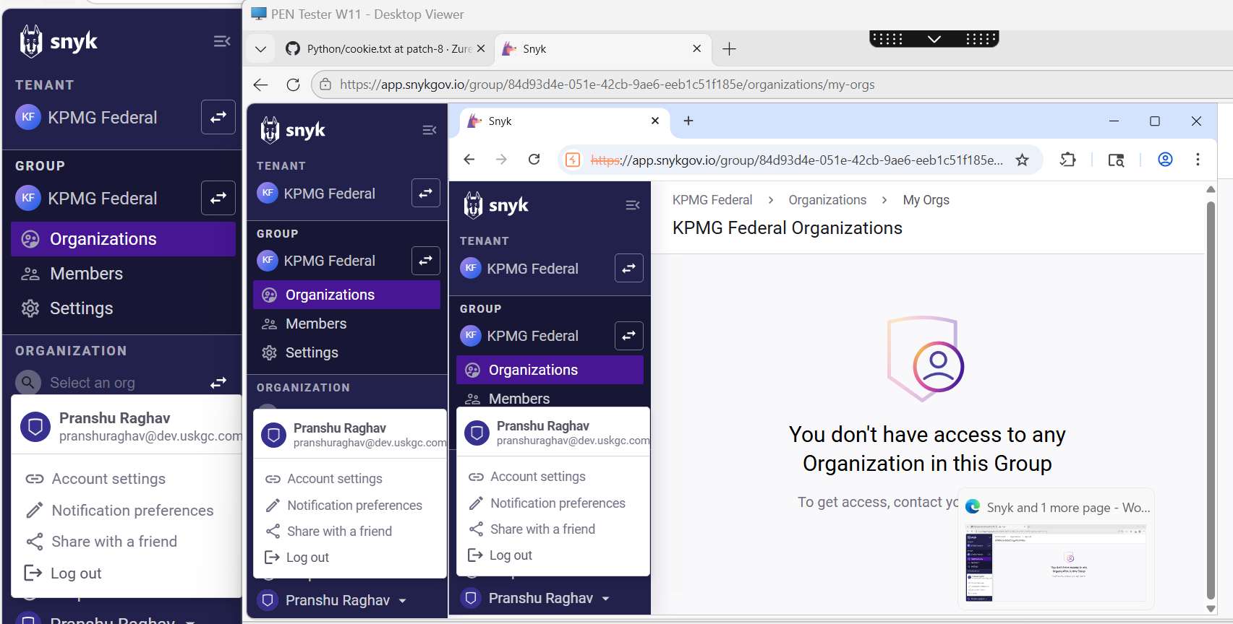
Figure 1

Remediation:

- It Okta Admin console under global session policy configure the number of maximum concurrent session per user – set to 1 to force single session.
- Action on new login – either terminate the oldest session or prompt the user
- Snyk should invalidate all existing sessions for a user upon a new successful authentication. This is a standard session management – on login success, the server queries all active sessions for that publicID and marks them expired before issuing the new one.

Closing/Downgrading Justification:

Appendix

Risk Rating Criteria
Overall Risk Rating Matrix
Likelihood | Impact
 | Negligible | Minor | Moderate | Significant | Severe
Very High | Low | Medium | High | High | Very High
High | Low | Medium | Medium | High | High
Medium | Low | Low | Medium | Medium | High
Low | Low | Low | Low | Medium | Medium
Very Low | Informational | Low | Low | Low | Low

Likelihood * Impact Risk Rating  Risk Rating Value  Very High 25  High 15-20  Medium 7-14  Low 1-6  Informational 1 | Risk Rating is determined by multiplying Impact * Likelihood  Examples:  Likelihood Low (2) * Impact Moderate (3) = 6 (Low)  Likelihood High (4) * Impact Moderate (3) = 12 (Medium)  Likelihood Very High (5) * Impact Severe (5) = 25 (Very High)

Impact Rating Guidance
Severe | Typically reserved for compromise (e.g. data exfiltration, ransomware) of DC3-type datasets, passwords/credentials with access to significant resources, or complete takeover of a system which has significant impacts to KPMG for lateral-based movement/attacks and disruption to the business (e.g. RP0/RP1-rated systems such as Active Directory).
Significant | Typically reserved for compromise (e.g. data exfiltration, ransomware) of DC3-type datasets, passwords/credentials with access to significant resources, or complete takeover of a system which has significant impacts to KPMG for lateral-based movement/attacks and disruption to the business.
Moderate | Typically reserved for compromise (e.g. data exfiltration, ransomware) of DC2-type datasets or partial takeover of a system which has moderate impacts to the business (e.g. RP2-rated systems such as a Business Application).
Minor | Typically reserved for compromise (e.g. data exfiltration, ransomware) of low-risk datasets such as DC1 or partial takeover of a system which has low impact of disruption to the business (e.g. RP3/4-rated systems).
Negligible | Reserved to document findings which have no material impact to KPMG or the Business.

Terminology
Depending on likelihood and impact, the findings will be assigned to one of the following risk ratings:
Very High
Very high risk findings represent a severe weakness that can be easily exploited by an adversary, leading to a direct and immediate impact on the business. This could include a full system compromise, significant data exfiltration, or a widespread denial-of-service condition. Such vulnerabilities pose the highest level of security risk.
Immediate action is required. For systems not yet in production, remediation must be completed before the "go-live" date. For production systems, remediation must be completed within five (5) days of the preliminary report date.

High
A high risk finding indicates a significant weakness that, if exploited, could result in substantial damage to business assets or reputation. Exploitation may require more specific conditions or attacker skill than a critical finding but still presents a high degree of security risk.
For systems not yet in production, remediation must be completed before the "go-live" date. For production systems, remediation must be completed within thirty (30) days of the preliminary report date.

Medium
A medium risk finding points to a moderate security weakness. While it may not lead to a full system compromise on its own, it could be leveraged by an attacker in conjunction with other vulnerabilities to achieve a greater impact or could result in minor data leakage or service degradation.
For systems not yet in production, remediation should be completed before the "go-live" date. For production systems, remediation must be completed within sixty (60) days of the preliminary report date.

Low
A low risk finding identifies a minor security weakness that has a limited potential for impact. Exploiting such a flaw is often difficult or would result in minimal damage. These findings typically represent a minor security risk but should be addressed to maintain a strong security posture.
Remediation for low-risk findings is recommended to be included in the next scheduled product update or maintenance cycle.

Informational
An informational finding is an observation that does not represent an immediately exploitable vulnerability but highlights a deviation from security best practices, a configuration weakness, or unusual system behavior that could pose a risk in the future.
No formal Remediation SLA is defined for informational findings. These are provided for consideration to improve overall security hygiene.

Methodology
Our security assessment follows a structured methodology designed to provide comprehensive and rigorous testing, from initial discovery to final reporting.

Reconnaissance and Discovery
The engagement begins with defining the external attack surface. We conduct reconnaissance to map the client's internet-facing infrastructure, using a combination of public sources and specialized tools. The objective is to identify all associated IP blocks, hostnames, domains, and subdomains. This process reveals the full scope of potential targets and informs the subsequent stages of the assessment.

Threat Modeling and Analysis
Following discovery, each in-scope application is analyzed to create a comprehensive threat model. We map critical information flows, business logic, user roles, architectural dependencies (e.g., web servers, APIs, databases), and third-party components. This analysis allows us to identify likely threat actors, define key attack vectors, and prioritize testing efforts based on the application's unique risk profile.

Application Enumeration and Profiling
With the attack surface defined, we actively enumerate the target applications to build a detailed service and functionality profile. Using a variety of tools and manual techniques, we gather in-depth information about the application's structure, technologies, and exposed resources. This intelligence gathering is crucial for identifying specific modules, functions, and configurations that will be targeted during vulnerability testing.

Vulnerability and Security Control Analysis
This is the core testing stage where we execute a comprehensive vulnerability assessment to identify security weaknesses. Our methodology is guided by industry-standard frameworks, including the OWASP Top 10, CWE Top 25, and MITRE ATT&CK®. We employ a combination of automated scanning and rigorous manual testing to evaluate the effectiveness of existing security controls across several key categories:
- Information Gathering
- Configuration and Deployment Management
- Authentication and Authorization
- Session Management
- Input Validation and Sanitization
- Cryptography and Data Protection
This hybrid approach ensures we identify both known vulnerabilities and complex, logic-based flaws that automated tools often miss.

Exploitation and Impact Validation
This activity validates the real-world impact of vulnerabilities identified during the assessment. We perform controlled exploitation of discovered weaknesses to determine the severity and potential business impact. By simulating adversarial tactics, we demonstrate how an attacker could compromise the application, escalate privileges, or access sensitive data, providing clear evidence of the risk.

Mitigation and Remediation Strategy
Based on the findings from the engagement, we develop a comprehensive mitigation plan. This includes providing tactical recommendations for addressing each specific vulnerability, as well as strategic guidance on secure development practices to enhance the overall security posture of the application.

Reporting
The final activity involves documenting all observations, findings, and recommendations in a formal report. Each vulnerability is assigned a risk rating based on the Common Vulnerability Scoring System (CVSS v3.1) and mapped to relevant CWE identifiers. The report delivers a clear, actionable summary for stakeholders and detailed technical analysis for engineering teams.

DSG Disclaimer Notice
Cybersecurity threats are continually changing, with new vulnerabilities discovered on a daily basis, and no application can ever be 100% secure no matter how much security testing is conducted. This report cannot and does not protect against personal or business loss as the result of use of the applications or systems described. DSG offers no warranties, representations or legal certifications concerning the applications or systems it tests.

All software includes defects: nothing in this document is intended to represent or warrant that security testing was complete and without error, nor does this document represent or warrant that the application tested is suitable to task, free of other defects than reported, fully compliant with any industry standards, or fully compatible with any operating system, hardware, or other application. By using this reported information, you agree that DSG shall be held harmless in any event.

Non-Production and Production Testing Advisory
It is important for the customer to understand that the engagement testing in non-production environments such as UAT (User Acceptance Testing) or QC (Quality Control) represents what is found only in such environments. If there are inaccuracies, omissions, or changes made during or after the testing engagement; this may impact findings visibility and ultimately the accuracy of this report. It is equally important to note that UAT and QC environments should ultimately mimic the production environment. DSG pen testers, unless at the request of the customer, do not typically perform testing within a production environment for general stability and safety concerns. If production testing is a requirement by the SRM (Security Relationship Manager), please create a separate PTI (Penetration Testing Intake) form for as such and notify the DSG pen testers.

Modifications during Testing Engagements
If the customer performs any modifications or changes to the testing environment during an engagement, this may adversely impact the accuracy of the report and findings. Customers should be prepared to freeze changes where possible. If it is not possible, please notify the DSG pen testers of the intended change, time of change, and to which assets it will affect.

Contact us

Digital Security Group
Adversarial Testing
US-DLBPGAdversarialTestingAll@kpmg.com

